2018 Black Hawk County
Adolescent Sexual Health Report Card

Together For Youth provided 556 Sexual Health Education sessions to 4,056 individual students (unduplicated) in Black Hawk County last year.
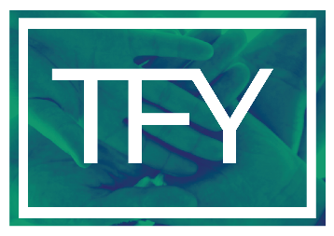
Together For Youth
(319) 269-9089
Sources: IDPH Bureau of HIV, STD, and Hepatitis and Bureau of Health Statistics

2018 Bremer County
Adolescent Sexual Health Report Card

*Five or less is masked by IDPH

Together For Youth provided 86 Sexual Health Education sessions to 639
individual students (unduplicated) in Bremer County last year.
Together For Youth
(319) 269-9089

Sources: IDPH Bureau of HIV, STD, and Hepatitis and Bureau of Health Statistics
2018 Buchanan County
Adolescent Sexual Health Report Card

Together For Youth provided 123 Sexual Health Education sessions
to 538 individual students (unduplicated) in Buchanan County last year.
Together For Youth
(319) 269-9089

Sources: IDPH Bureau of HIV, STD, and Hepatitis and Bureau of Health Statistics

2018 Butler County
Adolescent Sexual Health Report Card

*Five or less is masked by IDPH
Together For Youth provided 11 Sexual Health Education Sessions to
126 individual students (unduplicated) in Butler County last year.
Together For Youth
(319) 269-9089

Sources: IDPH Bureau of HIV, STD, and Hepatitis and Bureau of Health Statistics

